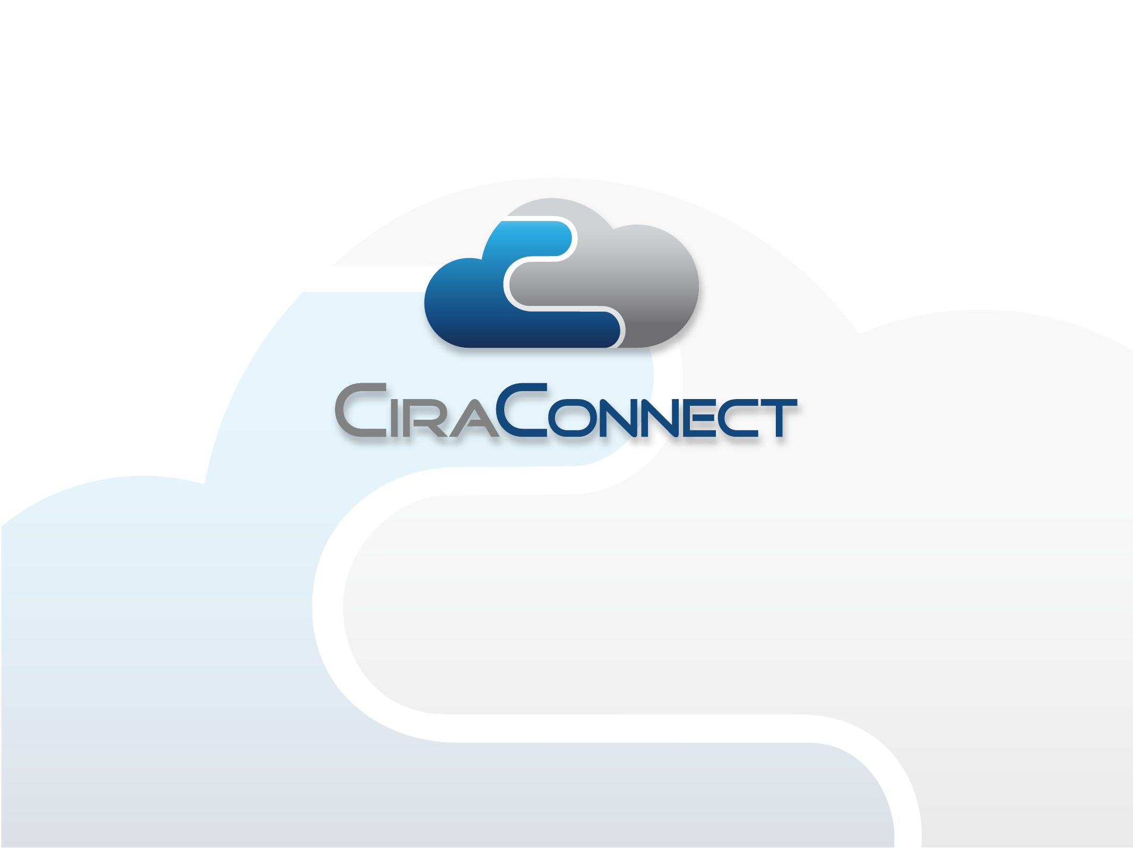
Introduction Information for
Co-ops and Self Managed Communities

Dear Board of Directors,

At CiraConnect, we focus on Customer Service and Standards of Excellence. We have a dedicated core group of employees who are experts in the industry and who will serve you well. CiraConnect employs a team of professionals that have years of experience managing and overseeing large scale developments of all kinds who are well equipped to serve the needs of your community and the residents.

We have also created an advanced, online cloud-based reporting platform that is available to all members 24/7, at www.CiraNet.com. Your client communities’ password enabled Board Portal allows each Board or staff members to fully access all of your client community’s Accounting Reports, Delinquency Reports, Deed Restriction Violations, Work Orders and other management tools via our web and mobile based applications. Homeowners can also access needed information, including payment status, call history, association announcements, etc., all via a password enabled Resident Portal.

Solutions for Self-Managed Communities

CiraConnect provides Co-ops and large, self-managed community board members and the homeowners they serve with a world-class, cloud based software solution and back-office shared services to augment your current operation and Community Association managers’ oversight into the day to day business affairs of your client communities. With comprehensive on-demand outsourced services from our shared services center, the Board of Directors have the option to employ fewer under-utilized, hard-to-retain employees such as IT, CPAs, marketing and other specialists. In addition, our cloud-based software platform provides less risk to the community as there are no upfront licensing fees or IT equipment expenditures.

Our world class web-based and mobile apps will greatly assist your management team and the Board of Directors providing key community information at their fingertips, anytime, anywhere.

Executive Management Team

Duane McPherson, CMCA®, PCAM®, Division President – Duane has over 25 years of property management experience. Duane has been certified by the Community Association Institute (CAI) as a Professional Community Association Manager (PCAM®), which is the highest professional certification available nationwide to managers who have advanced skills, knowledge and experience, since 1996. Prior to joining CiraConnect, Duane served as the GM/President of Spring Creek Association in Nevada for over 8 years. In this capacity, Duane had overall responsibility for the 5,400+ lot community which includes a golf course, campground, equestrian center, skeet range, 150 miles of road, parks, and numerous commercial properties within the community. Duane also owned his own property management firm managing community associations and other commercial property. Duane has industry experience in Nevada, California, North Carolina, Georgia, Florida and Texas and has lobbied at the state level for industry regulations.

Christopher O’Neill, Chief Executive Officer – Chris has twenty years of leadership experience with business services companies, focused on real estate. He is also currently on the board of directors of the leading management consulting firm dedicated to the global real estate industry. He has previously served on the board of directors of several other enterprises, including ten years on the board of the leading procurement solutions company to the multi-family real estate industry. Chris earned an MBA from Stanford University and earned both engineering and economics degrees from Rice University.

Monte Irion, Chief Process Officer – Monte has extensive experience in financial management, accounting and information technology management in real estate and financial services organizations. He also has significant financial experience with all aspects of real estate development and management. His work experience includes financial executive roles at Quanah Properties, Banc One Asset Solutions, and Prentiss Properties. He also worked as a Senior Accountant at Price Waterhouse. Monte is a Certified Public Accountant and he holds a BBA in Accounting from The University of Texas at Austin and an MBA in Finance from the University of North Texas.

Transition & Evaluation

Adding a service provider such as CiraConnect will allow you to get a fresh perspective of your operation metrics and operate more efficiently and assist with retention of your clients. As we transition properties, our professional staff evaluates every component of the client communities you have uploaded onto our platform. We will have multiple CPA’s, PCAM’s, Managers, and Maintenance Supervisory staff conducting the evaluation as part of the transition. Not only does our staff give you insight into the day-to-day business affairs of your community, we also act as a resource for the manager of your community. In many cases it is helpful for the onsite manger to have that resource when needed.

After completion of the transition and evaluation, you will see a dramatic difference in the operation of your client communities. There will be a decrease in the overall workload of your internal team and you will have the tools you need to keep a watchful eye over every community by overseeing the operations, not performing them. CiraNet will also give you complete access to all of your client communities’ documents and operational metrics. In the future, your association’s summary home page will provide a plethora of information on the performance of your client communities. This information is updated daily; including the daily balance of the association’s operating bank account. We will provide training for you to utilize CiraNet and understand the complex regulations that govern in your state.

Once we have completed our reviews and inspections and the transition & evaluation process is complete, you will then be able to recommend changes that can possibly reduce your community’s expenditures, and consequently your Board of Directors can reallocate money to needed projects or reserves.

The level of management that you desire can be customized to fit both the needs and the budget of your community. From a very high level of service, to a base level that may be more economically viable for some associations, or anywhere in between. We also have a dedicated maintenance newsletter and website production team available.

Thank you again and we look forward to the potential opportunity to meet with you.

Kindest regards,

Duane McPherson, PCAM®, CMCA®
Division President
Phone: (972) 380-3538
Email: duane.mcpherson@ciraconnect.com

The following is a sample of the services we provide. The exact services and service level agreement are specified in the executed management contract documents.

Community Management Services
- Architectural Control Committee Service:
- Upload requests and copied of plans from Owners
- Management may forward request to board committee
- Notify Owner of the status and online Committee or Board approvals

- Resident Service Center:
- Provide Resident Service Center System
- Provide trained Resident Advisors to provide personalized, multi-channel service and distribute information as appropriate
- Maintain owner database with contact history and interaction notes
- Monitor calls for quality of service and survey resident satisfactions

- Board Portal (CiraNet):
- Provide web-based document archive
- Provide web-based reporting system with DRV, call log, delinquency, AP, lot, directory, financial summary and benchmarking report

- Resident Portal (CiraNet):
- Provide web-based document archive
- Provide messaging system to notify Owners of coming events
- Provide web-based resident service system Owner statements, assessment information, deed restriction information, directory, online payment and online service request forms

Community Inspection Services
- Site Inspections and Deed Restriction Service (CiraInspect):
- Provide Deed Restriction Management system
- Provide Mobile Windows 7 or IPad IOS inspection software
- Provide picture storage of violations
- Maintain Association restrictions information database

Financial Management Services
- Financial Management Service (CiraAccount):
- Provide Accounting and Financial Software
- Manage Accounts Payable
- Manage Accounts Receivable
- Manager General Ledger
- Prepare a proposed annual budget and forecast
- Bank account maintenance (additional fees apply for bank loan management
- Reconcile monthly bank statements
- Manage disbursements
- Perform the required document process
- Generate statements of account and/or resale certifications
- Facilitate cash management
- Prepare standard monthly financial reports no later than the 20th day of the following month-end and prepare standard year-end financial reports no later than the 45th day of the following year-end, each with standard account codes

- Manage Owner Assessments:
- Issue standard assessment coupons or statements
- Issue replacement coupon books
- Manage EFT/ACH payments process
- Manage credit card payment process
- Collect and post to proper bank account
- Process check without coupons and returned checks

- Statements of Account and Resale Process Service:
- Provide Statement of Account and Resale Process Management database
- Provide Online Closing Portal
- Answer tax service, title company and mortgage company inquiries
- Answer homeowner inquiries

- Transfer Process Service:
- Provide Transfer Process Management database
- Manage plat and lot/unit owner database
- Update Association records for new owner
- Generate transfer documentation

- Refinance Process Service:
- Provide Refinance Process Service database
- Answer tax service, title company and mortgage company inquiries
- Coordination of subordination agreement requests
- General refinance documentation

- Tax Service:
- Maintain updated plat information
- Collate information for any required Federal or State tax return preparation and forward to independent tax vendor selected by Association for preparation
- Maintain property tax accounts, parcel identifiers and property tax invoice payments
- Coordinate with the Association on required signatures for the required tax returns and submit to the applicable taxing authority
- Prepare and issue W-2s and 1099s

- Insurance Service:
- Assist with the application of the following insurance policies as requested: liability; property; worker’s compensations; Directors & Officers; Errors & Omissions
- Maintain Association insurance policies including expiration dates and renewals

- New Owner Welcome Process (CiraCommunicate):
- Mail out a welcome letter
- Maintain and update welcome packet and/or make information available online

Administrative and Collections Services
- Fulfillment Service:
- Provide on demand community mailing services for regular mailings, special notices and annual meeting notices as required up to a maximum number of mass mailings at three pages each in black and white

- Delinquent Assessment Collections (CiraAccount):
- Provide delinquency service system
- Create and mail standard delinquency notices
- Create legal referral packet and submit to Association’s attorney or collection agency
- Coordinate with the Association attorney post referral
- Process bankruptcy correspondence and file Proof of Claim on behalf of Association
- Receive, research, review and process foreclosures documents for subsequent conveyance and collection
- Provide delinquency report
- Assess, collect and post late fees

Community Communications Services
- Newsletter Publishing Service (CiraCommunicate):
- Create, scan and format logo for use with the Newsletter
- Layout newsletter template
- Write, edit and format articles
- Take, scan and format photos
- Maintain resident database
- Publish, print and mail newsletter
- Post newsletter to CiraNet board portal
- Post newsletter to CiraCommunity Website (if applicable)

- Website Software and Hosting Service (CiraCommunicate):
- Set-up hosting agreement
- Domain registration
- Scan or format photographs provided by Association
- Create logo, scan and format for use with the Website
- Design the website
- Set-up the names Association Administrator access and provide a base level of one hour of e-mail support during Manager’s regular business hours
- Provide Association hosted Website

Cloud-based Reporting Technology

Board Portal via CiraNet.com
The Board Portal is a cloud-based reporting portal developed to enable your board and committee members to better manage their community through intuitive, cloud-based reports that allows them real-time access to pertinent community information such as:

- Financial reports
- Legal documents (Bylaws, Articles of Incorporation, DCCRs)
- Work Orders and Task Logs
- Deed Restriction Violation (DRV) summary and drill down reports
- Delinquency logs
- Call log reports
- Resident directory
- Detailed list of all lot information
- Vendor invoices, book balances, open AP and expense detail pivot table

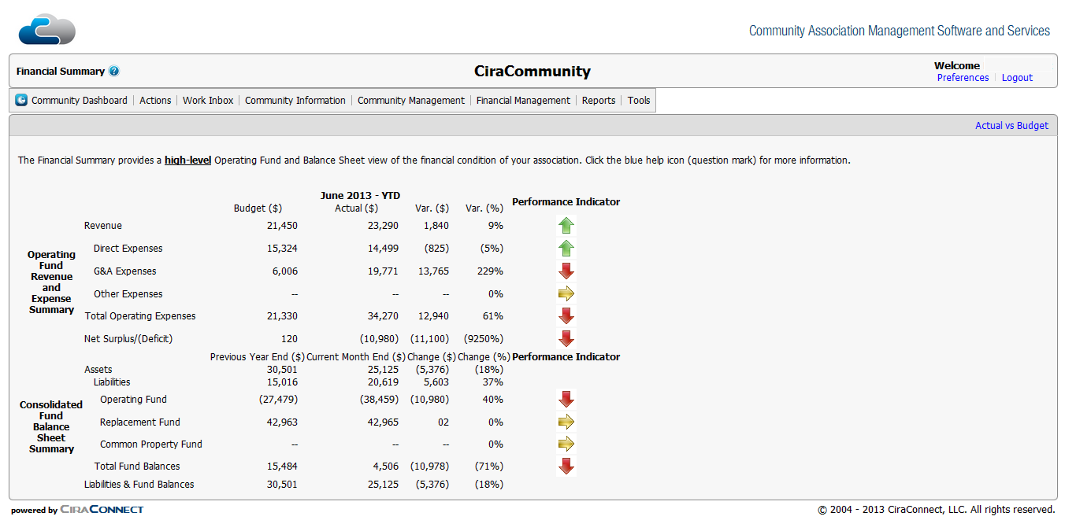

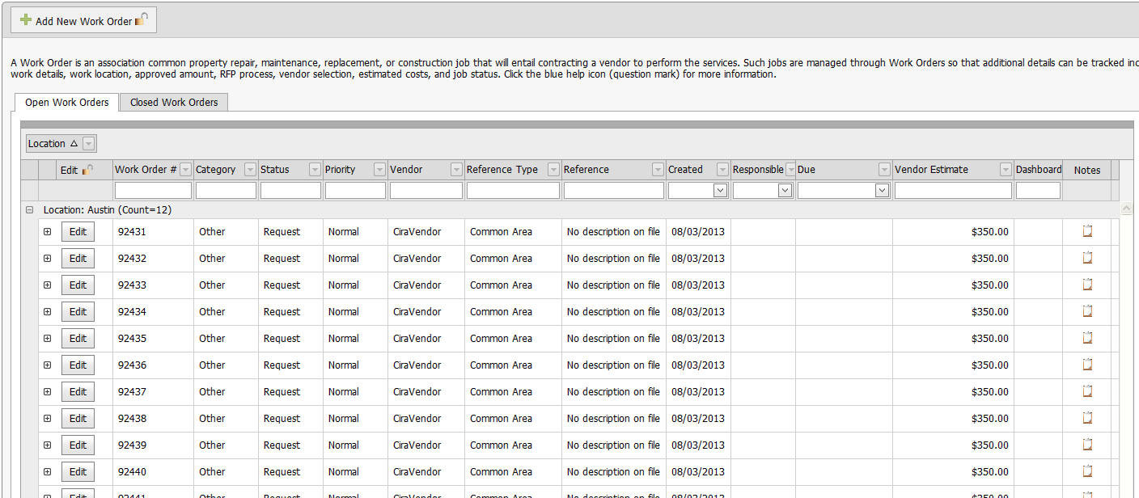

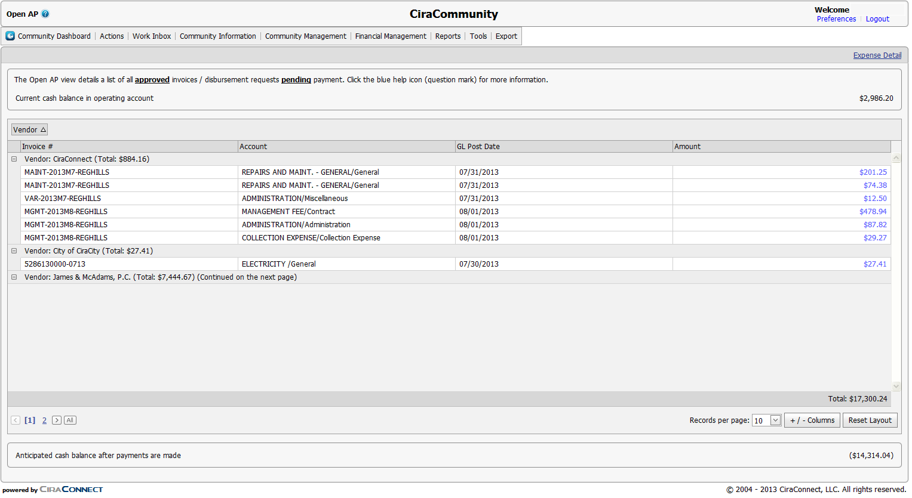

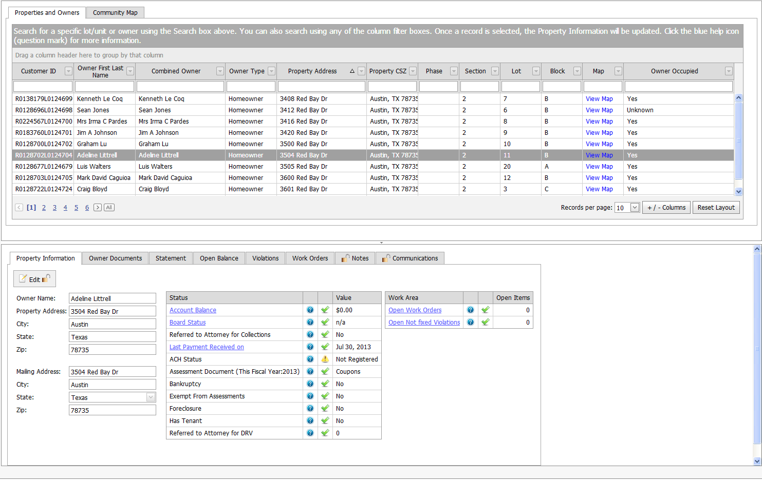

Resident Portal

The Resident Portal is a unique service that enables residents and homeowners to better manage their affairs with their community association through a secure, intuitive, cloud-based reporting portal with up-to-date access to pertinent community information such as:

- Owner statements and payment history
- Deed restriction summary
- Deed restriction violation reporting
- Board member directory
- Owner directory
- Online Payments
- Online service requests
- Assessment rules information

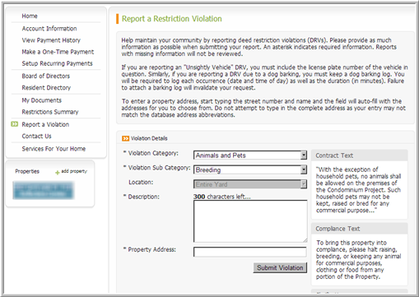
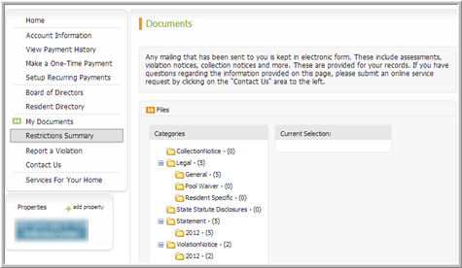
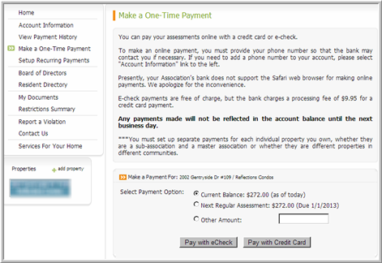
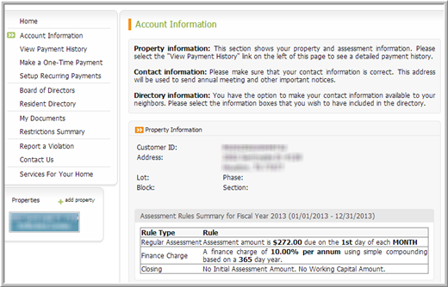

Cloud-based Reporting Technology

In conjunction with the cloud-based portals, CiraConnect provides extensive access and tools to manage the day to day business affairs of the community with complete processes on the go, in a familiar app interface and interactive graphic displays via its web and mobile based applications. This technology is:

- Accessible  - Compliant  - Configurable  - Easy-to-Use  - Process-centric  - Role-based  - Scheduled | - Cloud-Based  - Comprehensive  - Controlled  - Integrated  - Reportable  - Scalable  - Supported

Web Based Applications

Our industry leading web-based applications allow the onsite manager and Board of Directors to manage the community’s:

- Projects and tasks  - Community information  - Calendar  - Vendor Management  - Architectural applications  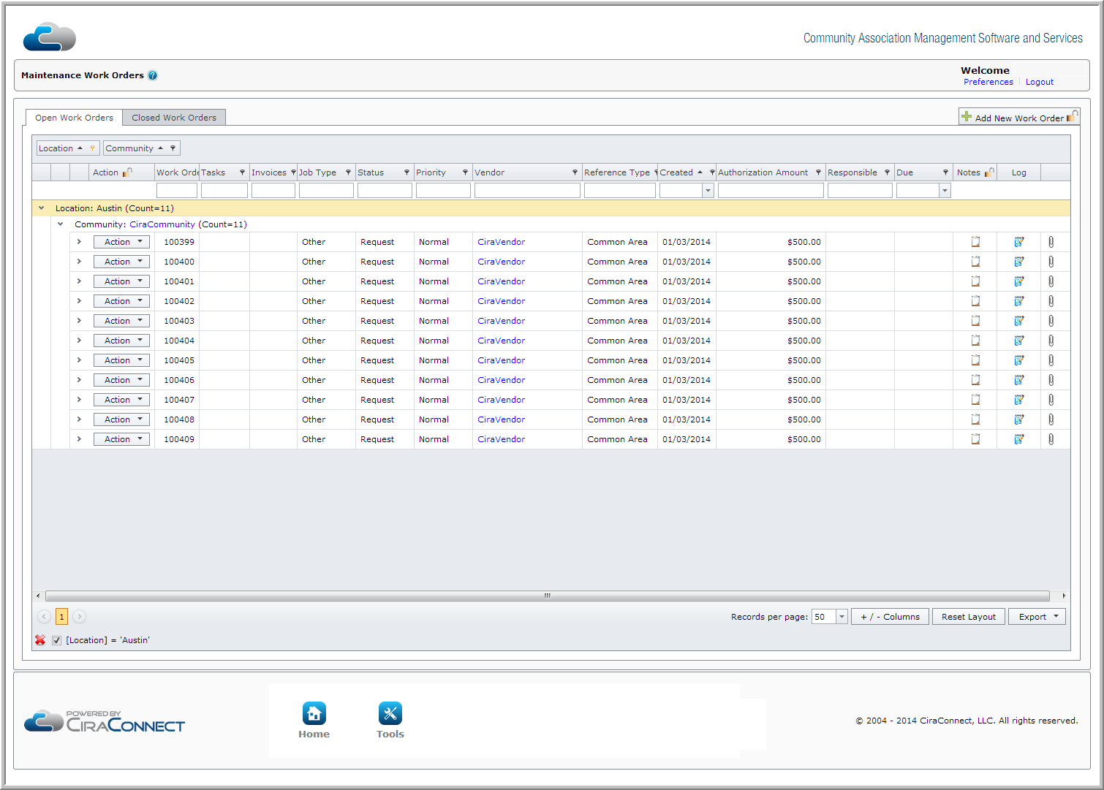 | - Emails  - Resident information  - Maintenance work orders  - Financials  - Deed restriction processes

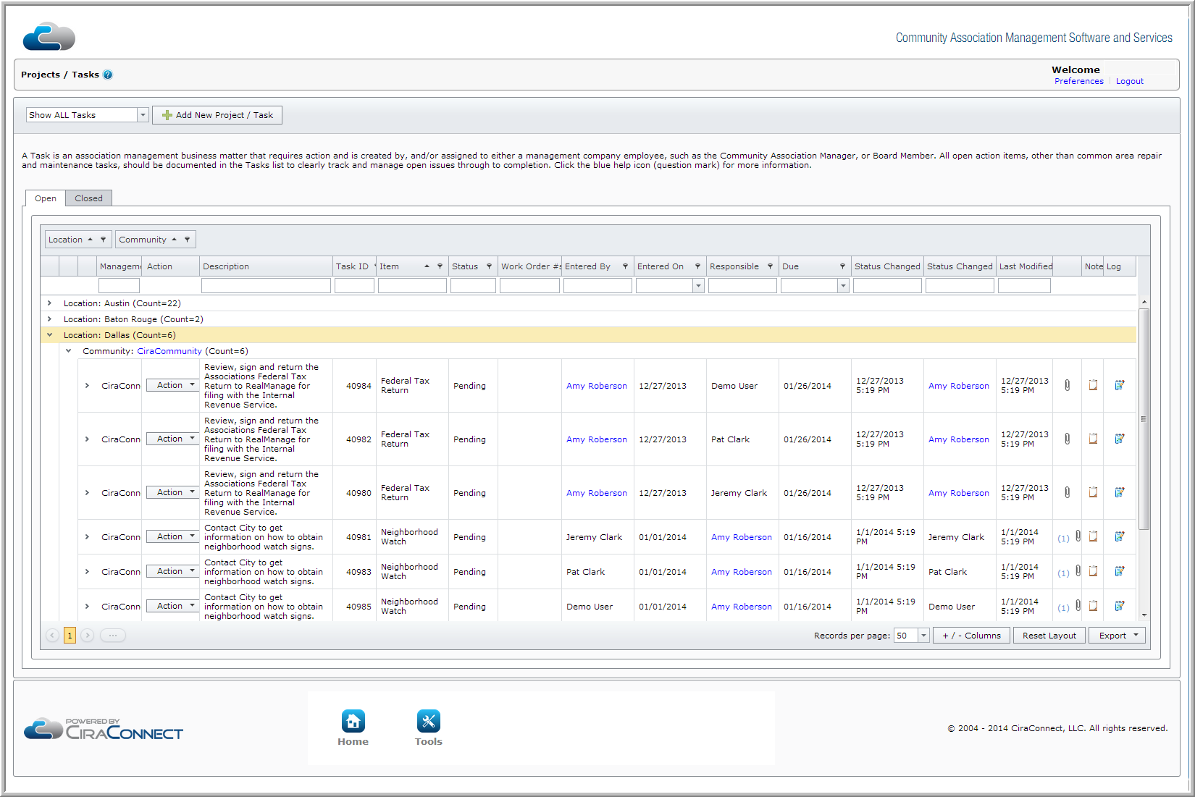

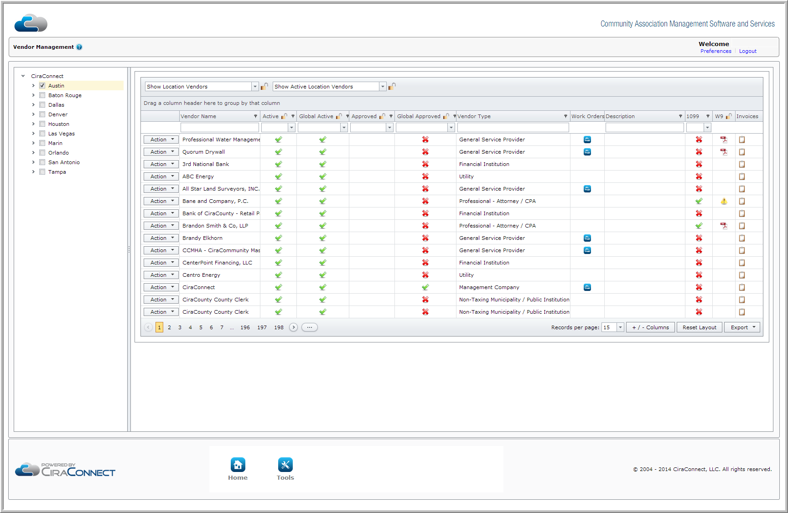

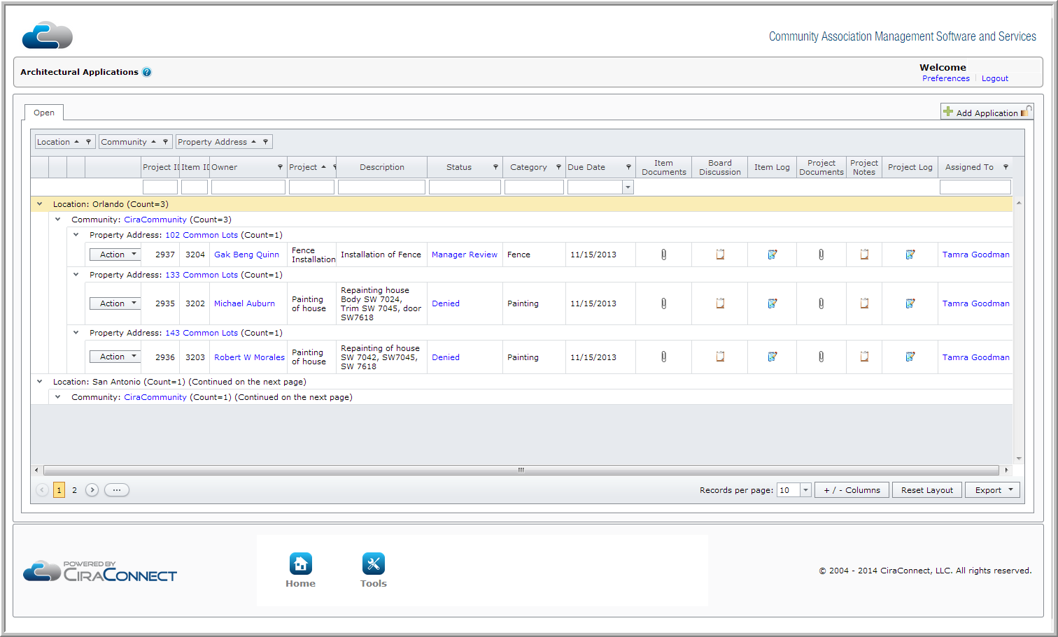

Mobile Based Applications

Our industry leading mobile technology allows the onsite management staff or Board of Directors to mange processes in real time including:

- Add/update projects / tasks
- Submit invoices using the camera or locally saved files
- Access and work the Board/Committee Work Box
  - Invoice approval
  - Collection referral approval
  - Architectural request approval
- Update maintenance work order
- Access property and owner information
- Contact information
- Account information
- Violation information

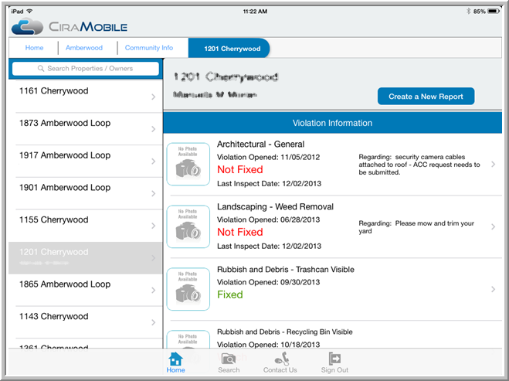

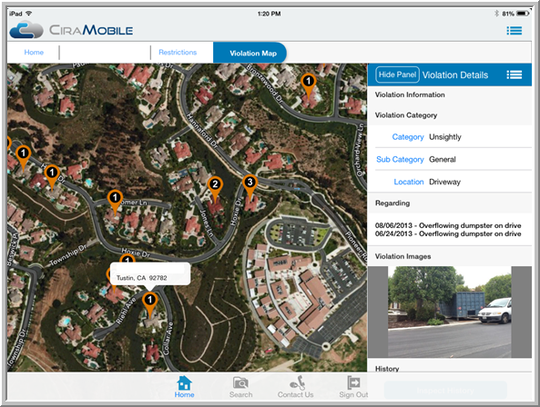

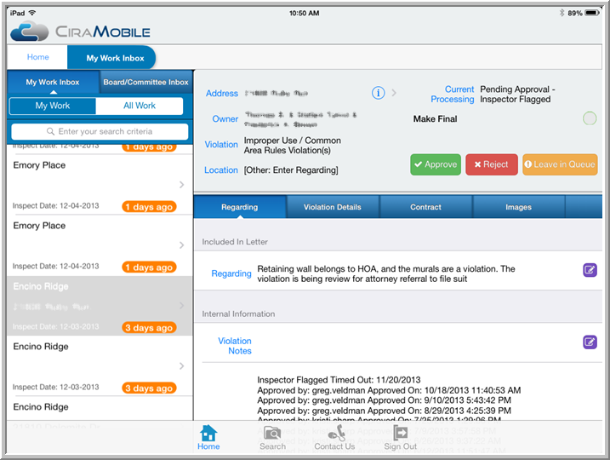

Management Report

CiraConnect provides the industry leading transparency and visibility into the business affairs of your client communities. Our intuitive Management Report provides a true 360°-review of our level of service conducted on a monthly basis provided in .pdf format for your review. With its extensive views into the business affairs of the community, it allows for better, more informed decisions on a timely basis. This consultative, value added tool, for both Community Association Managers and your client board members, works in conjunction with our cloud-based board portal, resident portal and Monthly Financial report.



